|  |  |  |  |  |  |
| --- | --- | --- | --- | --- | --- |
| **SCHOOL OF COMPUTER SCIENCE AND ARTIFICIAL INTELLIGENCE** | | | **DEPARTMENT OF COMPUTER SCIENCE ENGINEERING** | | |
| **Program Name:** M. Tech/MCA | | **Assignment Type: Lab** | | | **AcademicYear:**2025-2026 |
| **Course Coordinator Name** | | Venkataramana Veeramsetty | | | |
| **Course Code** |  | **Course Title** | | AI Assisted Problem Solving Using Python | |
| **Year/Sem** | I/I | **Regulation** | | R24 | |
| **Date and Day**  **of Assignment** | Week1 - TUESDAY | **Time(s)** | |  | |
| **Duration** | 2 Hours | **Applicable to**  **Batches** | | M. Tech/MCA | |
| **AssignmentNumber:2.3**(Present assignment number)/**24**(Total number of assignments) | | | | | |
| **Name: Syeda Afifa Fthima Rollno:2503B05142 Batch: M.Tech(CSE)** | | | | | |

**TASK ASSIGNMENT #1**

* **Use Google Gemini in Colab to write a function that reads a CSV file and calculates mean, min, max.**

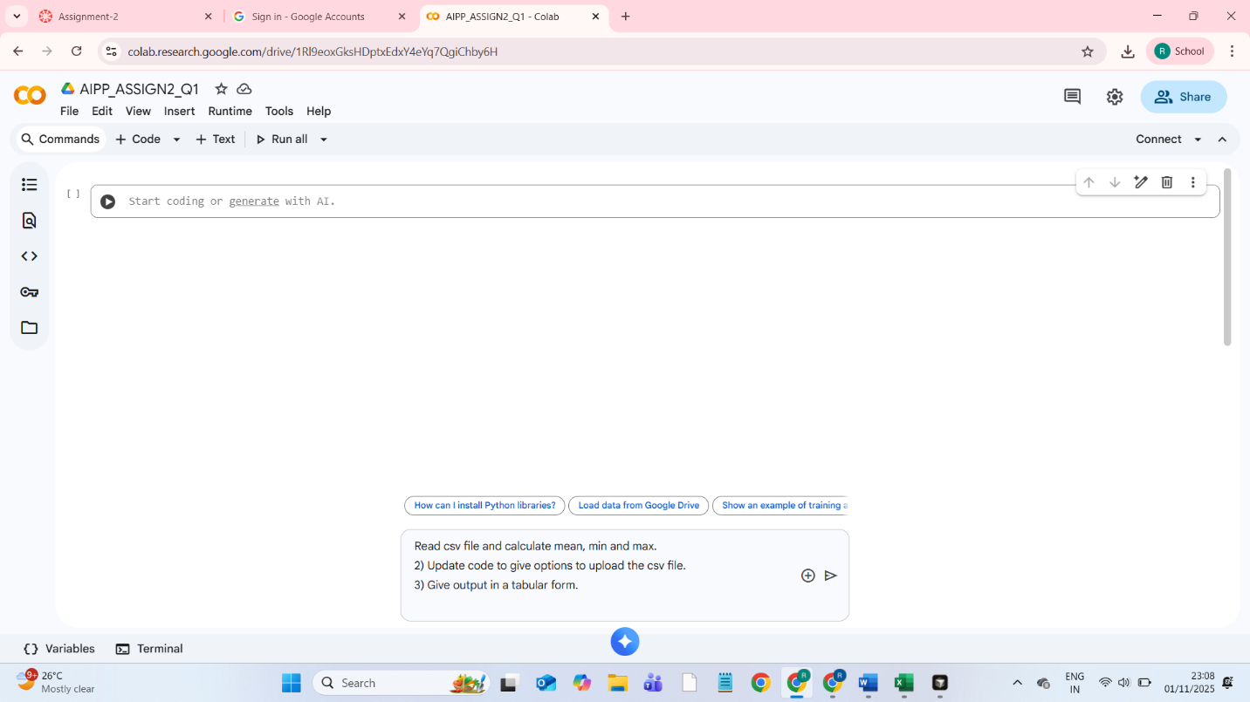

**PROMPTS:** 1) Read csv file and calculate mean, min and max.

2) Update code to give options to upload the csv file.

3) Give output in a tabular form.

**CODE:**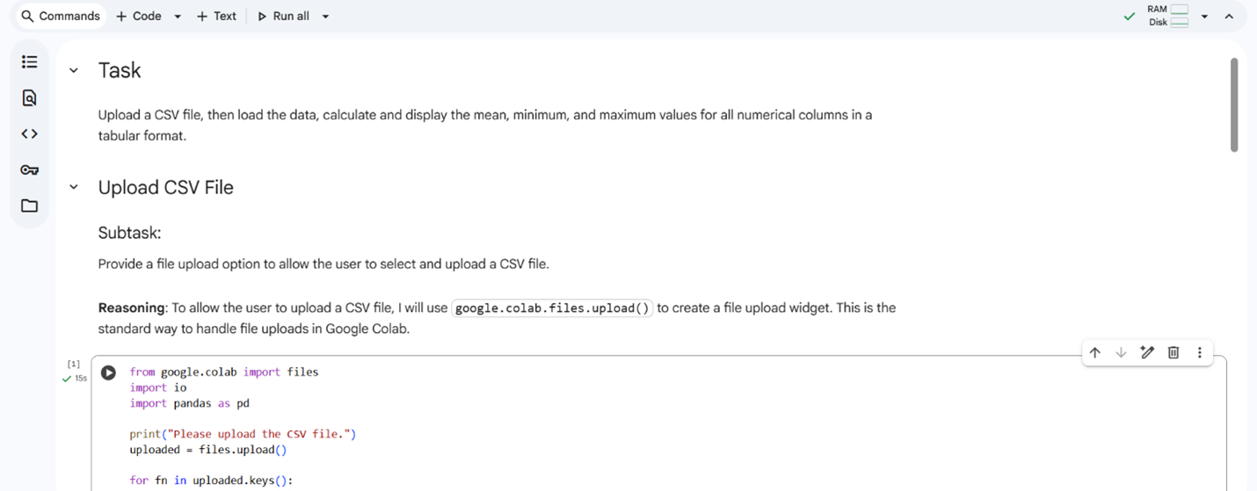

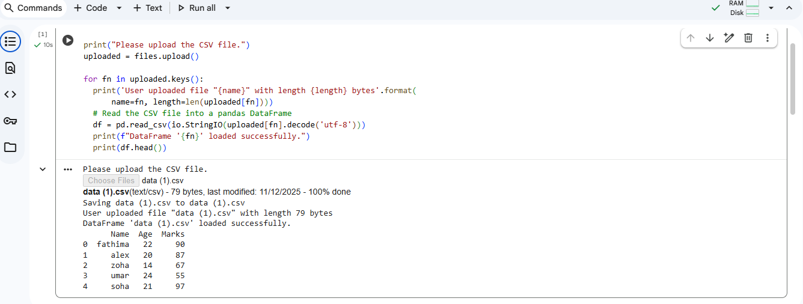

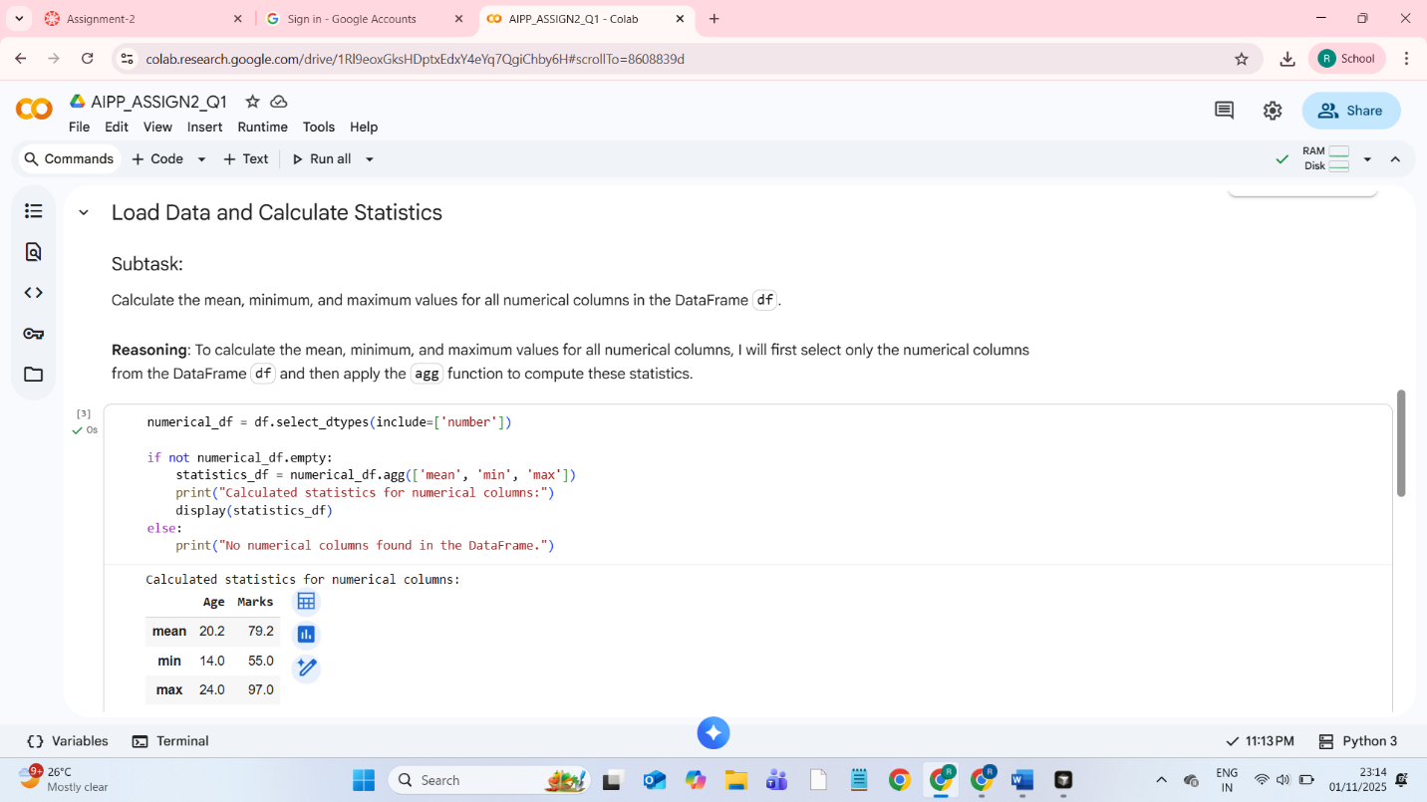

**TASK DESCRIPTION #2**

* **Compare Gemini and Copilot outputs for a palindrome check function.**

**PROMPT:**

1) Write function to check if string is Palindrome.

2) Read the input string from user.

**CODE USING GEMINI:**

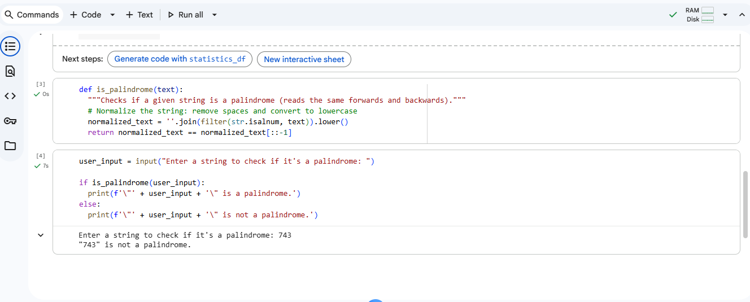

**CODE USING COPILOT:**  
  
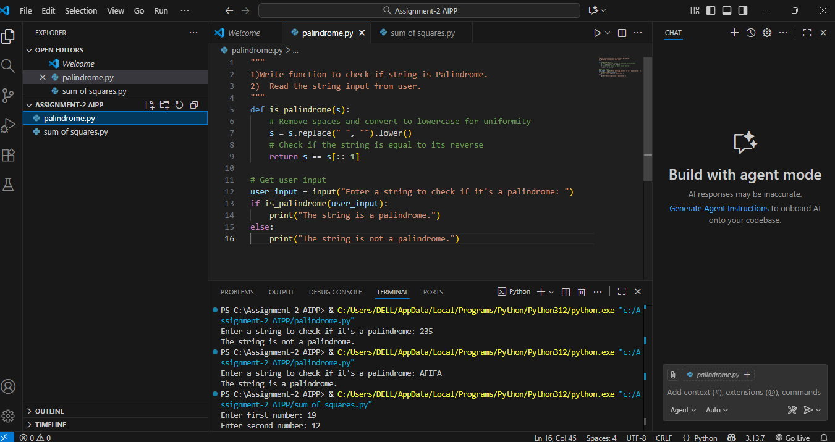

***OBSERVATIONS AND COMPARISON:***

**GITHUB COPILOT (VS CODE)**-

* More Advanced and Modular
* Includes optional arguments for customization.
* Can handle case sensitivity and non-alphanumeric filtering independently.
* Suitable for reuse in larger programs.
* Automatically test multiple strings, showing batch results.

**GEMINI (GOOGLE COLAB)** –

* Simpler and User-Friendly
* Easy for beginners.
* Lets the user enter their own string.
* The code is short and minimal.
* Good for interactive use or learning, not necessarily for advanced reuse.

**TASK DESCRIPTION #3**

* **Ask Gemini to explain a Python function (to calculate area of various shapes) line by line.**

**PROMPT:**

1) Give Dynamic code for shapes and print the area.

2) Explain python functions to calculate the area of shapes.

**CODE:**

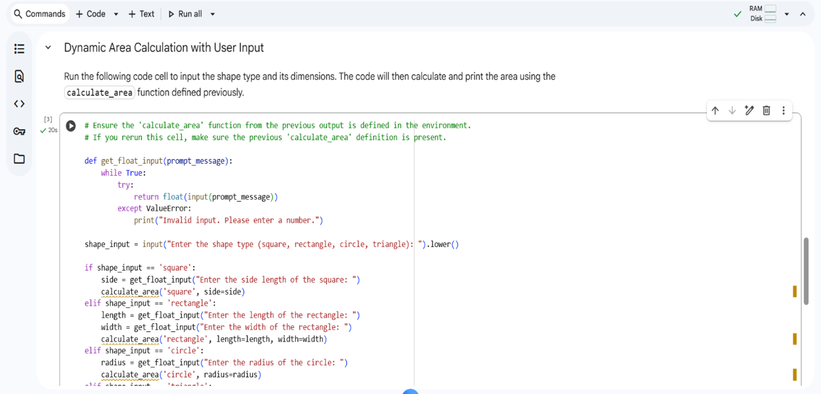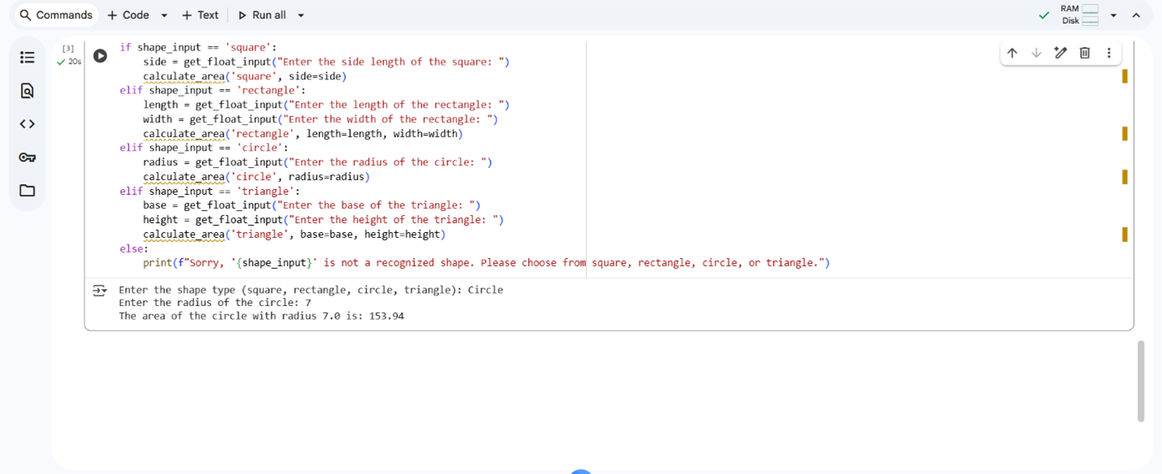

**Explanation of The Code Above:**

1. calculate_area Function Definition: This function (calculate_area(shape_type, **kwargs)) is defined to compute the area of different shapes. It takes the shape_type (like 'square', 'circle') and **kwargs for dimensions (like side, radius, length, width, base, height).
2. Shape Type Handling: Inside the function, it converts the shape_type to lowercase for case-insensitivity. Then, it uses if/elif statements to check the shape_type.
3. Area Calculation: Based on the shape_type, it retrieves the necessary dimensions from kwargs and applies the appropriate mathematical formula to calculate the area (e.g., side * side for a square, math.pi * (radius ** 2) for a circle).
4. Error Handling: If a required dimension is missing for a specific shape, or if the shape_type is not recognized, it prints an error message and returns None.
5. User Input Section: This part of the code prompts the user to enter a shape_type and then asks for the relevant dimensions based on the chosen shape. It includes a get_float_input helper function to ensure the user enters valid numbers.
6. Function Call: Finally, it calls the calculate_area function with the user's input to calculate and display the area of the specified shape.

**TASK DESCRIPTION #4**

* **Install and configure Cursor AI. Use it to generate a Python function (e.g., sum of squares).**

PROMPTS:

**1.Generate sum of squares of two numbers and input should be given by user.**

CODE WITH OUTPUT:

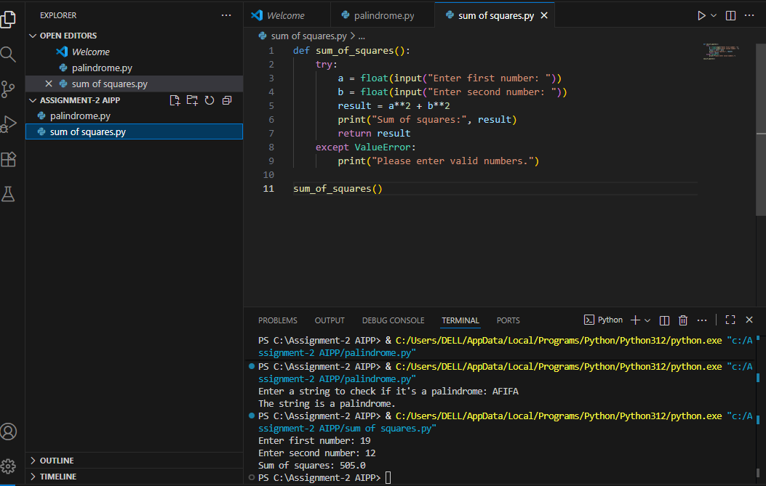

**TASK DESCRIPTION #5**

* **Student need to write code to calculate sum of odd number and even numbers in the list**

**PROMPT:**

**1) Refactor the above written code of sum of odd and even numbers to make it more efficient and reducing complexity.**

CODE WRITTEN BY ME:

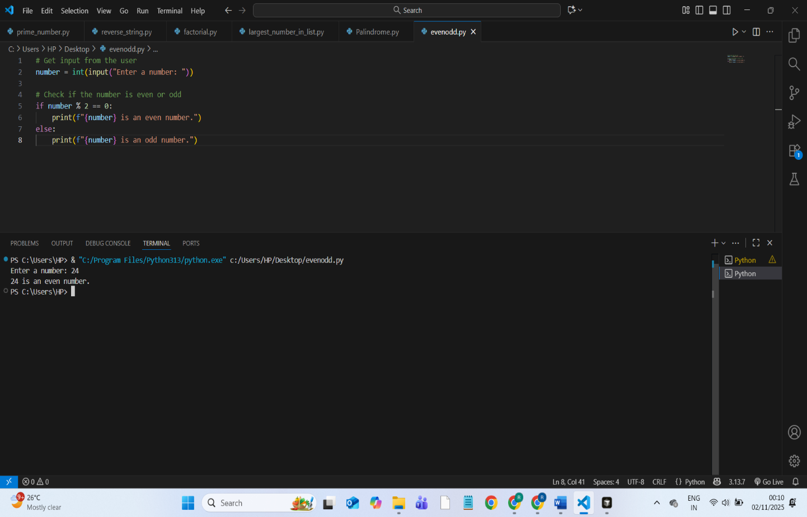

**CODE IMPROVED BY COPILOT:**

Prompt: """ refactor the following code to use a single-line conditional expression (ternary operator) """

